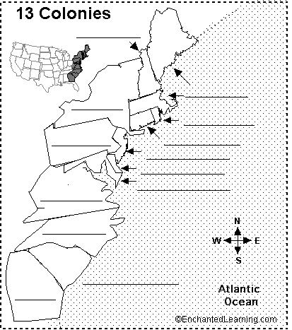

Name:___________________________

Period: __________

Date:__________________

**1 Massachusetts**

**2 New York**

**3 New Hampshire**

**4 Rhode Island**

**5 New Jersey**

**6 Georgia**

**7 Pennsylvania**

**8 Connecticut**

**9 Delaware**

**10 Maryland**

**11 Virginia**

**12 North Carolina**

**13 South Carolina**

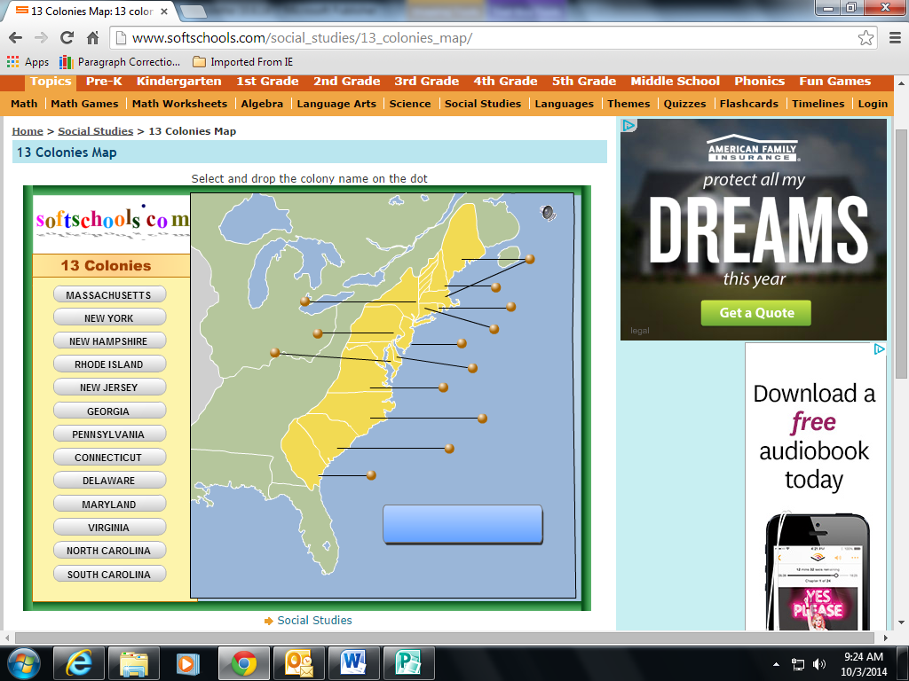

**1 Massachusetts**

**2 New York**

**3 New Hampshire**

**4 Rhode Island**

**5 New Jersey**

**6 Georgia**

**7 Pennsylvania**

**8 Connecticut**

**9 Delaware**

**10 Maryland**

**11 Virginia**

**12 North Carolina**

**13 South Carolina**

**Test 1**

Name:___________________________

Period: __________

Date:__________________